# Lab: Text Processing

Problems for in-class lab for the [Python Fundamentals Course @SoftUni](https://softuni.bg/trainings/3204/python-fundamentals-january-2021). Submit your solutions in the SoftUni judge system at <https://judge.softuni.bg/Contests/1739>

## Reverse Strings

You will be given series of strings until you receive an **"end"** command. Write a program that reverses strings and prints each pair on separate line in format **"{word} = {reversed word}"**.

### Examples

|  |  |
| --- | --- |
| **Input** | **Output** |
| helLo  Softuni  bottle  end | helLo = oLleh  Softuni = inutfoS  bottle = elttob |
| Dog  caT  chAir  end | Dog = goD  caT = Tac  chAir = riAhc |

### Hint

Read the first line and create a while loop until you receive "end"

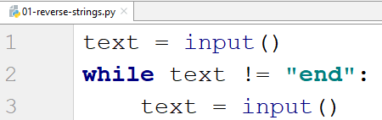

Now loop backwards through the text and add each character to a variable that stores the reversed string

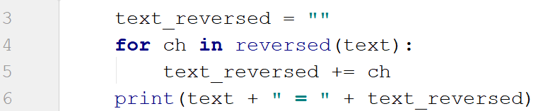

## Repeat Strings

Write a Program That Reads a **list of strings**. Each string is repeated N times, where **N** is the **length of the string**. Print the concatenated string.

### Examples

|  |  |
| --- | --- |
| **Input** | **Output** |
| hi abc add | hihiabcabcabcaddaddadd |
| work | workworkworkwork |
| ball | ballballballball |

### Hint

Start by reading the input and splitting it (we can receive multiple words)

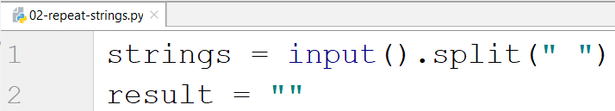

Loop through each word, get its length and add the repeated word to the result

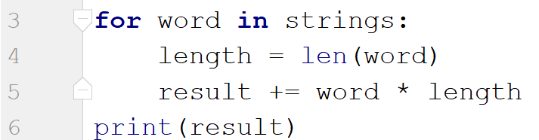

## Substring

On the **first line** you will receive a **string**. On the **second line** you will receive a second **string**. Write a program that **removes** **all** of the **occurrences** of the **first** string **in** the **second** **until** there is **no match**. At the end **print** the **remaining string**.

### Examples

|  |  |  |
| --- | --- | --- |
| **Input** | **Output** | **Comment** |
| ice  kicegiciceeb | kgb | We remove ice once and we get "kgiciceeb"  We match "ice" one more time and we get "kgiceb"  There is one more match. The finam result is "kgb" |

### Hints

First read the two lines

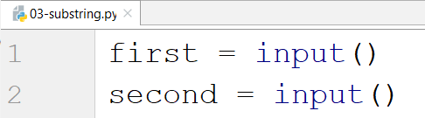

Create a while loop to remove the string if it is in the second string and print the result

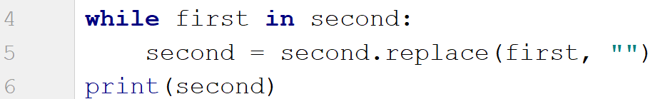

## Text Filter

Write a program that takes a **text** and a **string of banned words**. All words included in the ban list should be replaced with **asterisks** "**\***", equal to the word's length. The entries in the ban list will be separated by a **comma** and **space** "**,** ".

The ban list should be entered on the first input line and the text on the second input line.

### Examples

|  |  |
| --- | --- |
| **Input** | **Output** |
| Linux, Windows  It is not **Linux**, it is GNU/**Linux**. **Linux** is merely the kernel, while GNU adds the functionality. Therefore we owe it to them by calling the OS GNU/**Linux**! Sincerely, a **Windows** client | It is not *****, it is GNU/*****. ***** is merely the kernel, while GNU adds the functionality. Therefore we owe it to them by calling the OS GNU/*****! Sincerely, a ******* client |

### Hints

Read the banned words and the text

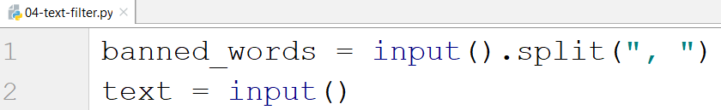

Loop through all the words and replace them with "*" while they are in the text

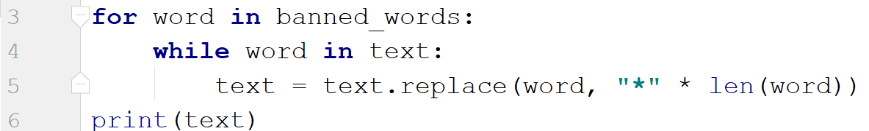

## Digits, Letters and Other

Write a program that receives a **single** **string** and on the **first** **line** prints **all the digits**, on the **second** – **all the letters**, and on the **third** – **all the other characters**. **There will always be at least one digit, one letter and one other characters.**

### Examples

|  |  |
| --- | --- |
| **Input** | **Output** |
| Mi2e | 53453  AgdDfgF  #^& |

### Hints

Read the input and create 3 empty strings for each type

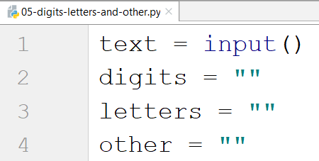

Loop through each character and check if it is digit, letter or other (Google how to check if a character is a letter in python)

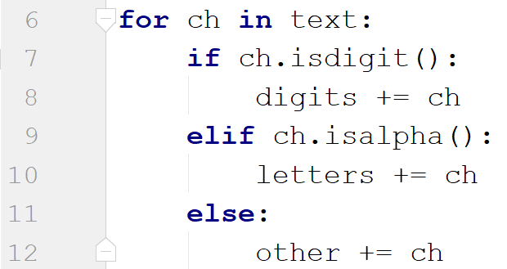

Print the result

